PLAIN PACKAGING

Countering Tobacco Industry Arguments

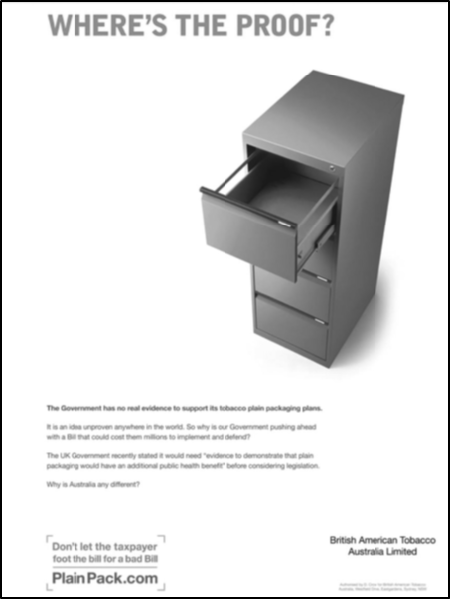Industry Argument There is no evidence that it will work to reduce smoking rates.

**Five independent systematic evidence reviews[1]** have been published that consider over seventy peer-reviewed scientific research studies, notable for their breadth and diversity of methods and for strong consistency in showing that plain packaging will contribute to reducing smoking rates. There is also four years post-implementation research and statistical data from Australia, all of which points towards the measure being effective.

The Chantler Review from the UK stated that all the evidence *“points in a single direction, and I am not aware of any convincing evidence pointing the other way.”*[2]

**None of the studies used by the tobacco industry to oppose plain packaging has been peer reviewed**; almost all were funded by the industry and have been the subject of serious criticism by academics and judges for their flawed methodology.[3]

**The official statistical evidence from Australia** shows an increase in the rate of decline of both smoking prevalence and tobacco consumption after implementation. The Post-Implementation Review (PIR) analysis attributes a 0.55 percentage point reduction in smoking rates to plain packaging, equivalent to 118,000 fewer smokers over the 34 months after implementation.[4]

British American Tobacco advertisement from the UK

Industry Argument It will increase the illicit trade in tobacco; plain packs are easier to counterfeit.

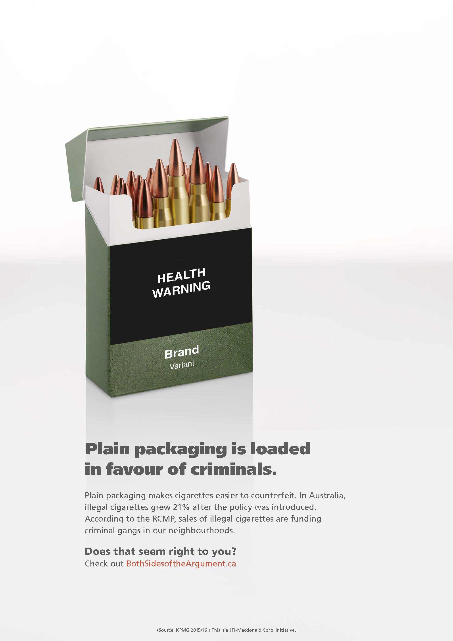

**Even Philip Morris has said that branded packs using the most complex holographic designs are already cheap and easy to counterfeit.**[5] Plain packaging retains colorful health warnings, tax stamps, and covert tracking codes and thus will not be significantly cheaper to counterfeit than existing packs.

Illicit trade is affected by supply and demand. Plain packaging does not increase demand for illicit tobacco but reduces overall demand for tobacco. Supply is impacted by effective enforcement action, which is also not effected by plain packaging.

**The tobacco industry has for years been complicit in the illicit market** by oversupplying low tax regimes.[6] The industry simply cannot be trusted in relation to the illicit market.

**In Australia, the proportion of illicit tobacco on the market has stayed the same** or reduced since implementation.[7]

The Customs and Revenue department in the UK produced a detailed report that concluded plain packaging will have no impact on the size of the illicit market.[8]

Advertisement on Japan Tobacco website in Canada

**The tobacco industry has exaggerated the data and manipulated the press** over this issue.[9]

**The only study relied on by the industry on illicit trade in Australia is by KPMG** in which the methodology used is fundamentally flawed.[10] The KPMG report finds that “*Through to the end of 2014, there has been no evidence of counterfeit plain packaging cigarettes.*” KPMG wrote to the UK government stating the report *does not* support “*the contention that plain paper packaging could lead of itself to an increase in tobacco smuggling.*”

**In their legal challenges to plain packaging, the tobacco companies submitted no supporting evidence, data, or experts** and made this claim “by mere assertion.”[11]

Industry Argument It will commoditize tobacco, leading to price reductions thereby increasing demand.

**After the introduction of plain packaging in Australia, tobacco companies continued to increase their prices in all market sectors**,over and above the tax rate increases.[12] Even if prices were to fall, this could be offset with increases in taxation.

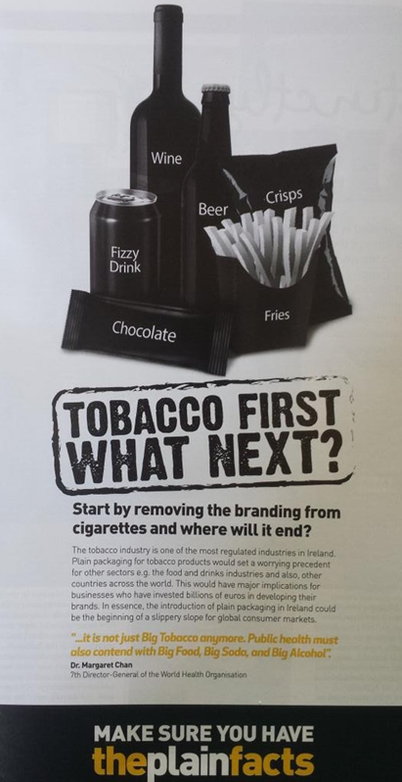Industry Argument It is the start down a “slippery slope” and will lead to plain packaging for other products.

**Tobacco is a uniquely damaging product that requires unique regulations**. Only tobacco control is the subject of the first and only public health international treaty. The aim of tobacco control is to eradicate all tobacco use and have a “tobacco-free society.” This is not the case for the regulatory control of other potentially unhealthy consumer products.

**The tobacco industry often uses the “slippery slope” argument to try to resist tobacco control measures,[13] such as health warnings**. To date, only tobacco products carry large graphic health warnings, so the slippery slope argument has not turned out to be true for other tobacco-control measures.

**Tobacco is the only product that the World Health Organization recommends plain packaging for[14].** Plain packaging of other products has not so far been proposed in any country that has adopted plain packaging of tobacco products. There is as yet very little research evidence in relation to plain packaging of other products that could support such proposals.

Industry Argument It breaches international and domestic intellectual property laws.

Japan Tobacco sponsored poster from Ireland

**Legal rulings in Australia, the UK, France, and the EU, as well as an international investment tribunal ruling have all confirmed tobacco-packaging regulations do not breach domestic or international intellectual property (IP) obligations**.[15]

**Disclosed internal tobacco industry documents** show that the tobacco companies received legal advice from their own lawyers and from the World Intellectual Property Organization that plain packaging would not breach international IP obligations because it only controls the use of trademarks and does not prevent registration of trademarks.[16]

**IP law gives the trademark owner the right to stop others from using the mark but does not give the owner the unfettered right to use the mark**. This has been confirmed by national courts, investment tribunals, and previous WTO panel rulings.[17]

The WTO dispute panel determining the complaint against Australia will soon produce its report and is expected to rule that there is no breach of the WTO TRIPS agreement on intellectual property. The ruling will be made public in July 2017. Governments in Australia, the UK, France, Ireland, Hungary, Norway, Slovenia, Georgia and New Zealand have carefully considered their WTO and international obligations and decided to proceed with plain packaging legislation.

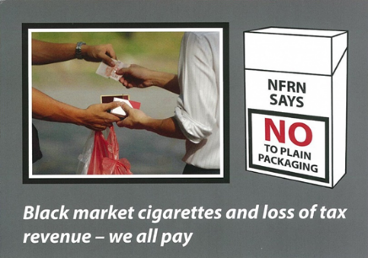Industry Argument It will cost small retail businesses by increasing serving times.

**In Australia, serving times quickly returned to normal and in some areas decreased** because tobacco was put in alphabetical order on shelves making brands easier to identify.[18]

PMI and BAT funded retailers associations in the UK and France to oppose plain packaging.[19]

Post card placed in small retailers across UK funded by National Federation of Retail Newsagents.

Tobacco retailers oppose all tobacco-control laws because they reduce the volume of tobacco sales, but this opposition has to be balanced against the huge health and economic benefits that come from fewer people smoking.

Industry Argument It will cause job losses in domestic tobacco-manufacturing industries.

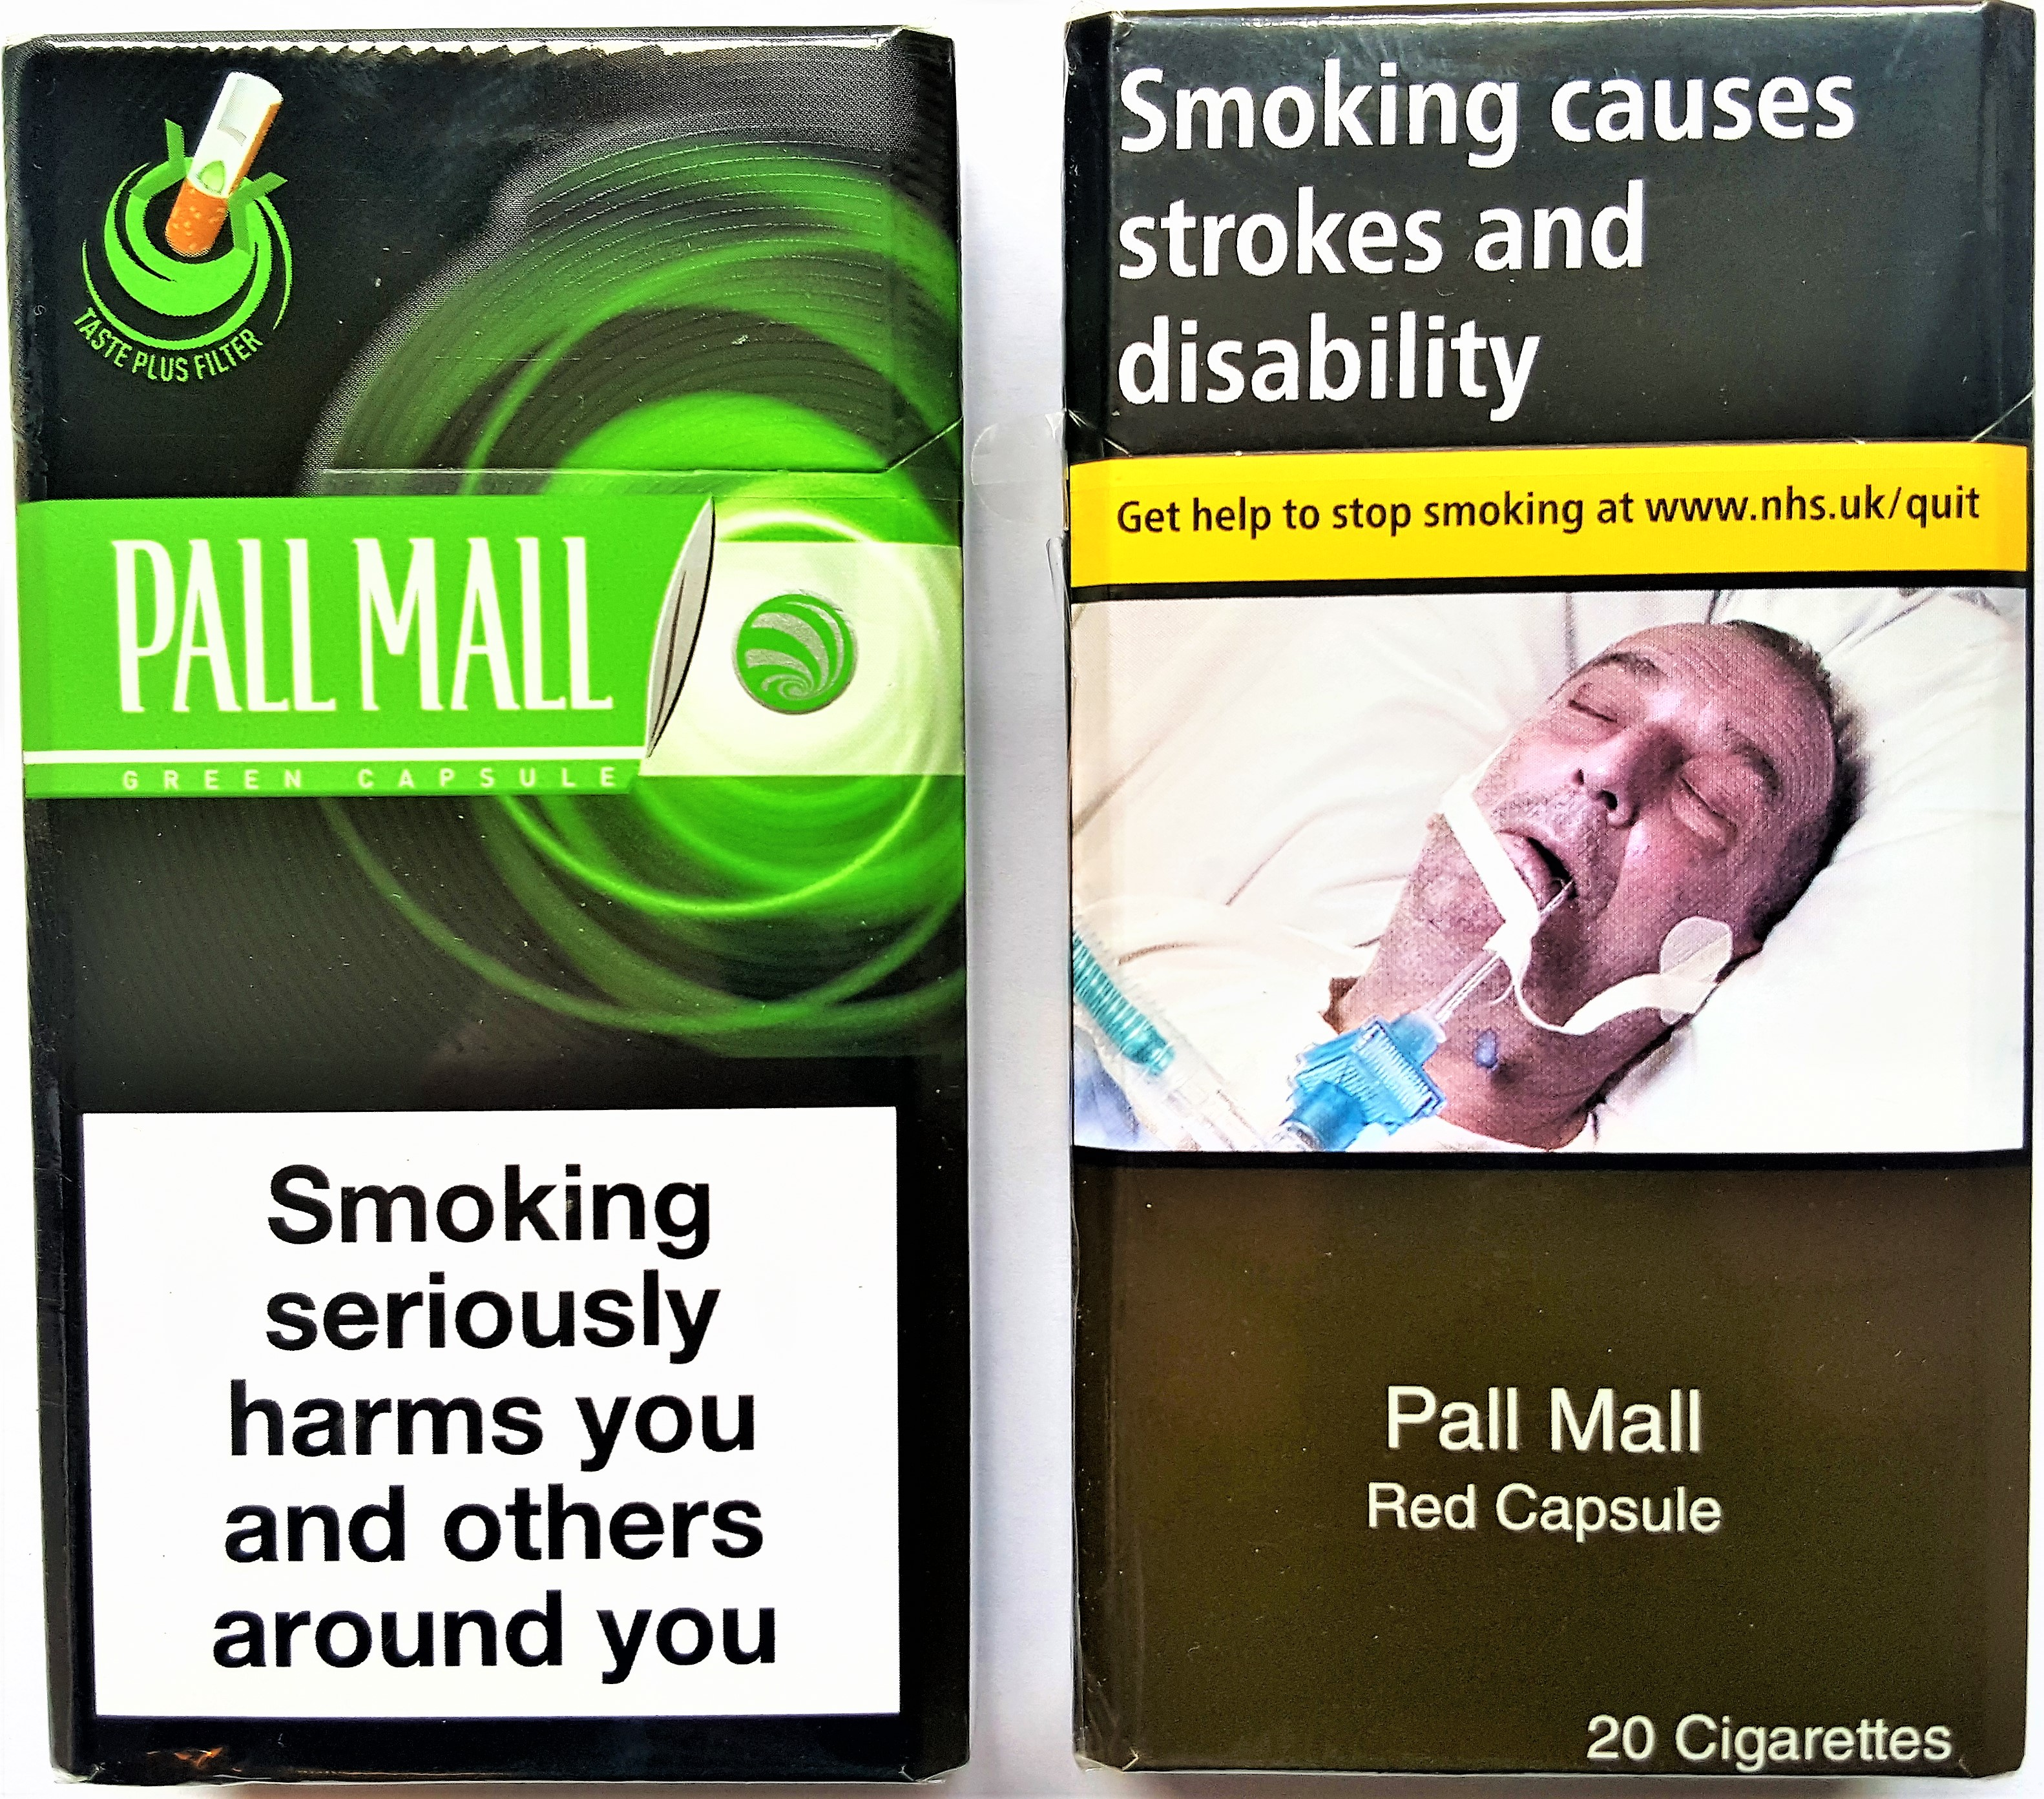

**This argument puts tobacco profits before the economic benefits to society. The economic benefits in reducing smoking rates are huge and far outweigh the costs to the industry**.

The Economic Impact Assessment for the UK showed that a 1 percentage point reduction in smoking rates resulting from plain packaging would lead to **£25 billion net benefit to the economy over ten years** due to reduced healthcare costs and increased productivity.[20]

**Reductions in smoking lead to significant healthcare savings in the short term**. A new study from the US showed that a 10% relative drop in smoking (meaning, for instance, a drop from 20% to 18%) would be followed by an expected $63 billion reduction in healthcare expenditure *the next year*.[21]

The tobacco industry consistently exaggerates the impact of tobacco-control measures on their ability to make profits. In rich economies where smoking rates are falling, tobacco company profits still continue to rise. The companies increase their prices over and above any tax rises and thus still increase profits.[22]



Money not spent on tobacco by those that have quit is then spent on other goods, generating alternative employment. Studies show that most countries see no net job losses and that a few see net gains if consumption falls.[23]

Industry Argument Branding on packs only goes to “brand switching” and market share and not to smoking initiation or overall consumption.

**The WHO Framework Convention on Tobacco Control and its guidelines** recognize that tobacco packaging and product design are “important elements of advertising and promotion” and recommend standardized packaging as a “means of eliminating the effects of advertising or promotion on packaging.”

**Packaging is recognized as an important component in of the overall marketing strategy for *all consumer goods***. Tobacco is no exception. Packaging is particularly important for consumer products with a high degree of social visibility, such as cigarettes. Unlike many other consumer products, cigarettes are in packages that are displayed each time the product is used and are often left in public view between uses.

Pall Mall Capsule cigarette packs before and after UK plain packaging laws. The promotional effects of the old packaging are clear.

**The US Surgeon General** summarized evidence in 2012 and 2014 and concluded that: “*The evidence is sufficient to conclude that advertising and promotional activities by the tobacco companies cause the onset and continuation of smoking among adolescents and young adults.”*[24]

1. Cancer Counsel Victoria (Australia 2011); Stirling Review (UK 2012 and updated 2014); The Chanter Review (UK 2014); The Hammond Review (Ireland 2014); and the Cochrane Review (international 2017)
2. See <http://www.kcl.ac.uk/health/10035-TSO-2901853-Chantler-Review-ACCESSIBLE.PDF> at paragraph 6.2.
3. In the tobacco companies’ legal challenge to plain packaging in the UK, the High Court Judge stated that the evidence put forward by the tobacco companies was not peer reviewed, either ignored or airily dismissed the worldwide research and literature base, and was frequently unverifiable. He made detailed critiques of each of the expert reports put forward by the tobacco companies and concluded that this “body of expert evidence does not accord with internationally recognised best practice” [R (British American Tobacco & Ors) *v.* Secretary of State for Health [2016] EWHC 1169 (Admin). para 374].
4. See <https://ris.govspace.gov.au/2016/02/26/tobacco-plain-packaging/>.
5. Philip Morris International, Codentify, Brochure, 2012: <http://www.pmi.com/eng/documents/Codentify_E_Brochure_English.pdf>
6. See <https://theconversation.com/tobacco-industry-rallies-against-illicit-trade-but-have-we-forgotten-its-complicity-38760>.
7. See <http://tobaccocontrol.bmj.com/content/24/Suppl_2/ii76.full>.
8. The UK HMRC assessment of illicit trade and plain packaging is available from: <https://www.gov.uk/government/uploads/system/uploads/attachment_data/file/403495/HMRC_impact_report.pdf>.
9. See <http://tobaccocontrol.bmj.com/content/23/e1/e35.full?sid=2fc80260-7458-44b1-89c2-af867a6caa8a>.
10. See <http://www.cancervic.org.au/downloads/plainfacts/Analysis_IllicitAusKPMG_full_year_2014_29May15.pdf> . The KPMG report also contains a disclaimer that expressly states that it was produced to specific criteria set by the tobacco companies and should not be used for any purposes or persons other than the tobacco companies that commissioned the report.
11. R (British American Tobacco & Ors) *v.* Secretary of State for Health [2016] EWHC 1169 (Admin), paragraphs 609, 669, and 996.
12. See <http://tobaccocontrol.bmj.com/content/24/Suppl_2/ii90.abstract>.
13. S. Chapman and S. M. Carter. “Avoid health warnings on all tobacco products for just as long as we can”: a history of Australian tobacco industry efforts to avoid, delay and dilute health warnings on cigarettes. Tobacco Control 2003;12:iii13-iii22.
14. From the WHO website (accessed on 2 March 2017): <http://www.who.int/campaigns/no-tobacco-day/2016/faq-plain-packaging/en/index2.html>
15. R (British American Tobacco & Ors) *v.* Secretary of State for Health [2016] EWHC 1169 (Admin), in particular paragraph 40.

    JT International SA *v.* The Commonwealth of Australia [2012] HCA 43, High Court of Australia, Reasons October 5, 2012.

    The Queen on the Application of Philip Morris Brands SARL et al. *v.* Secretary of State for Health, Case C-547/14, CJEU (2016).

    Philip Morris Brands Sarl & Ors *v.* Oriental Republic of Uruguay ICSID Case No. ARB/10/7, in particular paragraphs 260–271.
16. See <http://www.tobaccotactics.org/index.php/Countering_Industry_Arguments_Against_Plain_Packaging:_It_Breaches_Intellectual_Property_Rights#cite_note-10>.
17. Confirmed in the UK in BAT v Secretary of State [2016]; and the tribunal ruling in Philip Morris Brands Sarl *v.* Uruguay. See note 11.
18. See <http://tobaccocontrol.bmj.com/content/early/2013/05/25/tobaccocontrol-2013-050987.abstract>.
19. See <http://tobaccotactics.org/index.php/BAT_Funded_Lobbying_Against_Plain_Packaging>

    <http://tobaccotactics.org/index.php/Astroturfing>.
20. The economic impact assessment from the UK is available from: <https://www.gov.uk/government/uploads/system/uploads/attachment_data/file/403493/Impact_assessment.pdf>.
21. See <http://journals.plos.org/plosmedicine/article?id=10.1371/journal.pmed.1002020>.
22. See <http://onlinelibrary.wiley.com/doi/10.1111/add.12159/full>.
23. This was the conclusion of a report for the World Bank: Curbing the epidemic: governments and the economics of tobacco control. Available from: <http://tobaccocontrol.bmj.com/content/8/2/196.full> . For instance, on page 69, it states “A study in the United States found that the number of jobs would rise by 20,000 between 1993 and 2000 if all domestic consumption was eliminated.”
24. United States Department of Health and Human Services, Surgeon General (2014). Surgeon General’s Report on Smoking and Health.